***Dt : 20/9/2022***

***Note:***

***=>All WrapperClass objects are automatically Immutable Objects.***

***=>The frameworks like JCF(Java Collection Framework),Hibernate,..***

***will hold the data only in the form of Objects,because of this***

***reason we have to make Primitive datatypes available inthe form of***

***Objects.***

***===============================================================***

***faq:***

***define Annotations?***

***=>The tag based information which is added to the programming***

***Components like Variable,method,Class and Interface are known as***

***Annotations.***

***=>we use '@' symbol to represent annotations.***

***=>These annotations will provide information to compiler at***

***Compilation stage or will provide information to executioncontrol***

***at execution stage.***

***=>The following are some important annotations in CoreJava:***

***(i)@Override***

***(ii)SuppressWarnings***

***(i)@Override:***

***=>@Override annotation will provide information to Compiler at***

***compilation stage to check the method is Overriding method or not.***

***(ii)SuppressWarnings:***

***=>@SuppressWarnings annotation will provide information to***

***compiler at compilation stage to remove the raised Warnings.***

***============================================================***

***\*imp***

***define 'Object' Class?***

***=>'Object' class is from java.lang package and which is default***

***ParentClass or SuperClass of all the classes declared in the***

***application.***

***=>The following are some important methods of 'Object' class:***

***1.hashCode()***

***2.toString()***

***3.clone()***

***4.equals()***

***5.wait()***

***6.notify()***

***7.notifyAll()***

***8.getClass()***

***9.finalize()***

***Diagram:***

***=============================================================***

***\*imp***

***Arrays in Java:***

***=>The sequenced collection of elements of same datatype is known***

***as Array.***

***(or)***

***=>The sequenced collection of objects generated from same class***

***is known as Array.***

***(or)***

***=>The Sequenced collection of Simimiler Objects is known as Array.***

***Types of Arrays:***

***=>Arrays are categorized into two types:***

***1.Single Dimensional Arrays***

***2.Multi-Dimensional Arrays***

***1.Single Dimensional Arrays:***

***=>The Arrays which are represented with one dimension are known***

***as Single Dimensional Arrays or 1-D Arrays.***

***syntax:***

***Class_name arr_var[] = new Class_name[size];***

***--------------------------------------------------***

***Ex-Program:***

***wap to read and display Integer WrapperClass objects?***

***DemoArray1.java***

***package maccess;***

***import java.util.*;***

***public class DemoArray1 {***

***@SuppressWarnings("removal")***

***public static void main(String[] args) {***

***Scanner s = new Scanner(System.in);***

***System.out.println***

***("Enter the size of Array to hold Integer Objects:");***

***int n = s.nextInt();***

***Integer a[] = new Integer[n];//Array Object***

***System.out.println("Enter "+n+" Integer Objects:");***

***for(int i=0;i<=n-1;i++)***

***{***

***a[i] = new ~~Integer~~(s.nextInt());***

***//Adding Integer object to Array***

***}//end of loop***

***System.out.println("===Display using old for loop====");***

***for(int i=0;i<=n-1;i++)***

***{***

***System.out.print(a[i].toString()+" ");***

***}***

***System.out.println("\n====Extend for(Java5)=====");***

***for(Integer k : a)***

***{***

***System.out.print(k.toString()+" ");***

***}***

***s.close();***

***}***

***}***

***o/p;***

***Enter the size of Array to hold Integer Objects:***

***5***

***Enter 5 Integer Objects:***

***12***

***11***

***23***

***21***

***22***

***===Display using old for loop====***

***12 11 23 21 22***

***====Extend for(Java5)=====***

***12 11 23 21 22***

***======================================================***

***Dt : 21/9/2022***

***Diagram:***

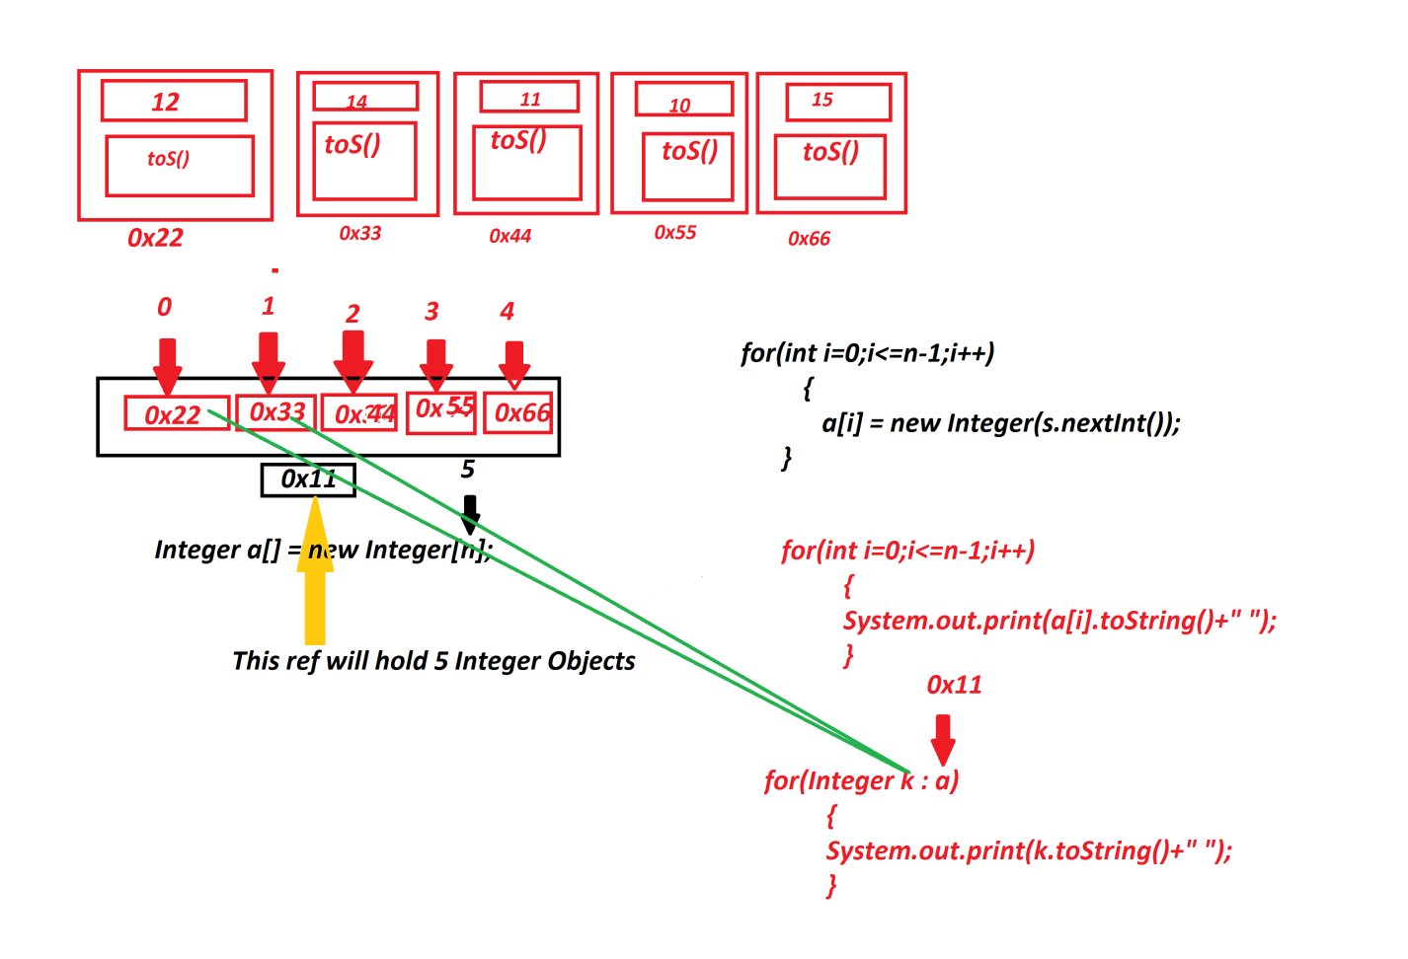

***faq:***

***define 'Extended for'?***

***=>'Extended for' introduced by Java5 version and which is used to***

***retrieve elements from Array Objects.***

***syntax:***

***for(Class_name var : Container_name)***

***{***

***//loop_body***

***}***

***Advantage:***

***=>'Extended for' is auto-executable loop in which we specify only***

***Container_name and type of data(Objects).***

***(There is no concept of Initialization,Condition and Incre/decre)***

***Note:***

***=>'Extended for' is also known as 'Enhanced for' loop or 'for each'***

***loop.***

***=======================================================***

***Ex-2:***

***wap to read and display String Objects using Arrays?***

***DemoArray2.java***

***package maccess;***

***import java.util.*;***

***public class DemoArray2 {***

***public static void main(String[] args) {***

***Scanner s = new Scanner(System.in);***

***System.out.println***

***("Enter the size of Array to hold String Objects:");***

***int n = Integer.parseInt(s.nextLine());***

***String a[] = new String[n];//Array Object***

***System.out.println("Enter "+n+" String Objects:");***

***for(int i=0;i<=n-1;i++)***

***{***

***a[i] = new String(s.nextLine());***

***//Adding String object to Array***

***}//end of loop***

***System.out.println("===Display using old for loop====");***

***for(int i=0;i<=n-1;i++)***

***{***

***System.out.println(a[i].toString()+" ");***

***}***

***System.out.println("====Extend for(Java5)=====");***

***for(String k : a)***

***{***

***System.out.println(k.toString()+" ");***

***}***

***s.close();***

***}***

***}***

***o/p:***

***Enter the size of Array to hold String Objects:***

***3***

***Enter 3 String Objects:***

***java is simple***

***java is secure***

***java is multi-threaded***

***===Display using old for loop====***

***java is simple***

***java is secure***

***java is multi-threaded***

***====Extend for(Java5)=====***

***java is simple***

***java is secure***

***java is multi-threaded***

***=======================================================***

***Assignment:***

***wap to read multiple strings using Arrays and display as follows:***

***i/p:***

***java***

***egg***

***ink***

***ant***

***thread***

***o/p:***

***java***

***gge***

***kni***

***tna***

***thread***

***===============================================================***

***Ex-3:***

***wap to read and display multiple Product details?***

***Product.java***

***package test;***

***public class Product {***

***public String code,name;***

***public float price;***

***public int qty;***

***public Product(String code,String name,float price,int qty) {***

***this.code=code;***

***this.name=name;***

***this.price=price;***

***this.qty=qty;***

***}***

***public String toString() {***

***return code+"\t"+name+"\t"+price+"\t"+qty;***

***}***

***}***

***DemoArray3.java(MainClass)***

***package maccess;***

***import java.util.*;***

***import test.Product;***

***public class DemoArray3 {***

***public static void main(String[] args) {***

***Scanner s = new Scanner(System.in);***

***System.out.println***

***("Enter the size of Array to hold Product Objects:");***

***int n = Integer.parseInt(s.nextLine());***

***Product a[] = new Product[n];//Array Object***

***System.out.println("Enter "+n+" Product details");***

***for(int i=0;i<=n-1;i++)***

***{***

***System.out.println("Enter the code:");***

***String code = s.nextLine();***

***System.out.println("Enter the name:");***

***String name = s.nextLine();***

***System.out.println("Enter the price:");***

***float price = Float.parseFloat(s.nextLine());***

***System.out.println("Enter the qty:");***

***int qty = Integer.parseInt(s.nextLine());***

***a[i] = new Product(code,name,price,qty);***

***//Adding Product object to Array***

***}//end of loop***

***System.out.println("===Display using old for loop====");***

***for(int i=0;i<=n-1;i++)***

***{***

***System.out.println(a[i].toString()+" ");***

***}***

***System.out.println("====Extend for(Java5)=====");***

***for(Product k : a)***

***{***

***System.out.println(k.toString()+" ");***

***}***

***s.close();***

***}***

***}***

***o/p:***

***Enter the size of Array to hold Product Objects:***

***3***

***Enter 3 Product details***

***Enter the code:***

***A121***

***Enter the name:***

***Mouse***

***Enter the price:***

***1200***

***Enter the qty:***

***12***

***Enter the code:***

***A002***

***Enter the name:***

***CDRR***

***Enter the price:***

***1400***

***Enter the qty:***

***14***

***Enter the code:***

***A234***

***Enter the name:***

***FDDR***

***Enter the price:***

***1500***

***Enter the qty:***

***15***

***===Display using old for loop====***

***A121 Mouse 1200.0 12***

***A002 CDRR 1400.0 14***

***A234 FDDR 1500.0 15***

***====Extend for(Java5)=====***

***A121 Mouse 1200.0 12***

***A002 CDRR 1400.0 14***

***A234 FDDR 1500.0 15***

***=================================================================***